浙 江 农 林 大 学
实 验 任 务 书

学号：201905010330
姓名：张智超
班级：计算机193班
任课老师：胡军国

浙 江 农 林 大 学
19学年—20学年第 2学期 数据结构实验任务书
专业名称： 计算机科学与技术 实验学时： 2
课程名称：数据结构 任课教师： 胡军国
实验题目：C/C++复习
实验环境： Visual C++
实验目的：
复习数据结构相关知识
实验内容：

这次实验共完成4个程序，内容如下：

- 输入10本图书的编号，名称，价格，并把这些图书的信息输出，每本书一行。
- 用数组实现。
(2)用链表实现。

图书信息的定义：
typedef struct {
char no[8]; //8位图书号
char name[20]; //书名
int price; //价格
}Book;

- 输入10位同学的姓名，学号，成绩，并把这些学生的信息输出，每位学生一行。并输出最高分，最低分和平均分。
(1)用数组实现。
(2)用链表实现。

学生信息的定义：
typedef struct {
char no[8]; //8位学号
char name[20]; //姓名
int score; //成绩
}Student;

实验结构：
需要完成4个程序，每个括号一个程序，要准备运行结果截屏和代码。

- 程序1
运行结果截屏以下：
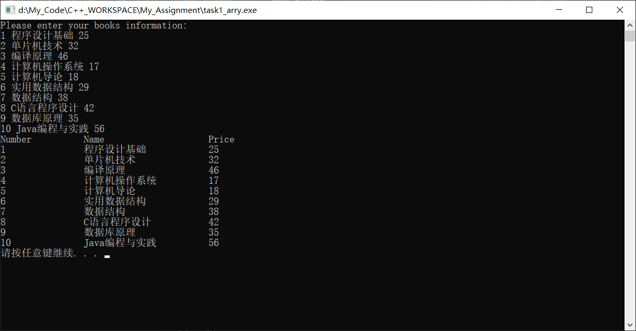

代码以下：
//输入10本图书的编号，名称，价格，并把这些图书的信息输出，每本书一行
#include<iostream>
#include<cstring>
#include<string>
using namespace std;

typedef struct book{
int number;
string name;
double price;
}book;

int main(){

book Allbooks[10]={0,"",0.0};
int i;
cout << "Please enter your books information: " << endl;

for(i=0;i<10;i++)
cin >> Allbooks[i].number >> Allbooks[i].name >> Allbooks[i].price;
cout << "Number\t\t" << "Name\t\t\t" << "Price" << endl;
for(i=0;i<10;i++){
cout << Allbooks[i].number;
cout << "\t\t";
cout << Allbooks[i].name;
cout << "\t\t";
cout << Allbooks[i].price << endl;
}
system("pause");
return 0;

}

- 程序2
运行结果截屏以下：
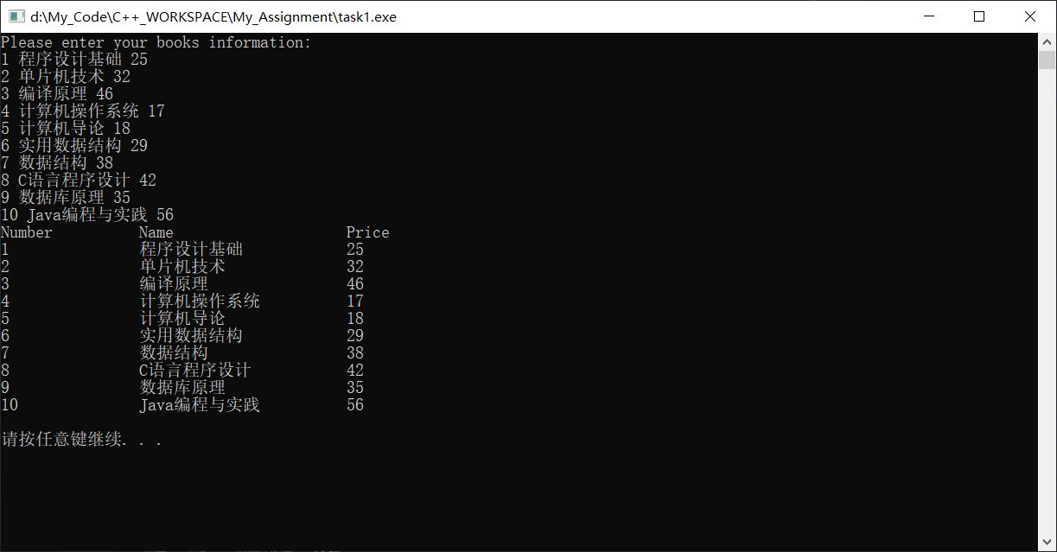

代码以下：
//输入10本图书的编号，名称，价格，并把这些图书的信息输出，每本书一行
#include<iostream>
#include<cstring>
#include<string>
using namespace std;

typedef struct book{
int number;
string name;
double price;
struct book* next;
}book;

//声明
book* Creatbook(int number1,string name1,double price1);
void Add(book* currentbook,int num,string nam,double pri);
void Print(book* currentbook);
void Destroy(book* currentbook);

int main(){
//初始化头结点
book* head = new book;
head->name = " ";
head->number = -1;
head->price = -1;
head->next =NULL;

int num;
double pri;
string nam;
cout << "Please enter your books information: " << endl;
for(int i=0;i<10;i++){
cin >> num >> nam >> pri;
Add(head,num,nam,pri);
}

Print(head->next); //输出打印
cout << endl;

Destroy(head); //收回内存
system("pause");
return 0;
}

book* Creatbook(int number1,string name1,double price1)
{ //创建结点
book* temp = new book;
temp->name = name1;
temp->number = number1;
temp->price = price1;
temp->next = NULL;
}

void Add(book* currentbook,int num,string nam,double pri)
{ //增加结点
while(currentbook->next!=NULL)
currentbook = currentbook->next;
currentbook->next = Creatbook(num,nam,pri);
}

void Print(book* currentbook)
{ //输出书籍
cout << "Number\t\t" << "Name\t\t\t" << "Price" << endl;
while(currentbook!=NULL){
cout << currentbook->number;
cout << "\t\t";
cout << currentbook->name;
cout << "\t\t";
cout << currentbook->price << endl;
currentbook = currentbook->next;
}
}
void Destroy(book* currentbook)
{ //收回空间
while(currentbook){
book* temp = currentbook->next;
delete currentbook;
currentbook = temp;
}
}

- 程序3
运行结果截屏以下：
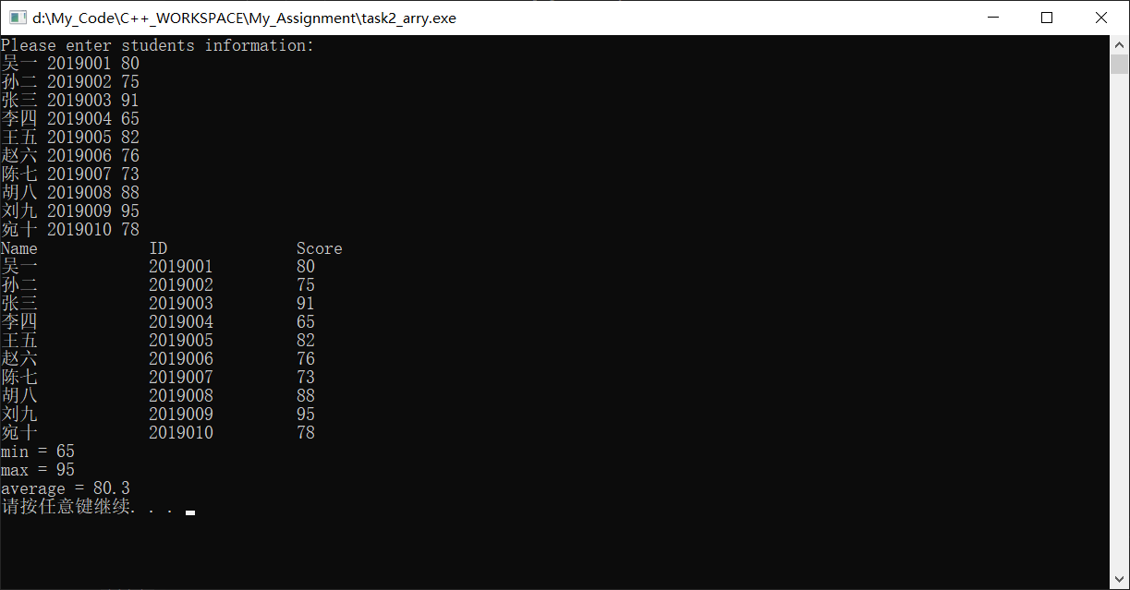

代码以下：
//输入10位同学的姓名，学号，成绩，并把这些学生的信息输出，每位学生一行。并输出最高分，最低分和平均分
#include<iostream>
#include<cstring>
#include<string>
#include<cfloat>
using namespace std;

typedef struct book{
string name;
int id;
double score;
}book;

int main(){

book Allstudents[10]={"",0,0.0};
int i;
double sum = 0.0;
double max = DBL_MIN;
double min = DBL_MAX;
cout << "Please enter students information: " << endl;

for(i=0;i<10;i++){
cin >> Allstudents[i].name >> Allstudents[i].id >> Allstudents[i].score;
sum += Allstudents[i].score;
}

cout << "Name\t\t" << "ID\t\t" << "Score" << endl;
for(i=0;i<10;i++){
if(Allstudents[i].score > max)
max = Allstudents[i].score;
if(Allstudents[i].score < min)
min = Allstudents[i].score;
cout << Allstudents[i].name;
cout << "\t\t";
cout << Allstudents[i].id;
cout << "\t\t";
cout << Allstudents[i].score << endl;
}
double average = sum/10;
cout << "min = " << min << endl;
cout << "max = " << max << endl;
cout << "average = " <<average << endl;

system("pause");
return 0;

}

- 程序4
运行结果截屏以下：
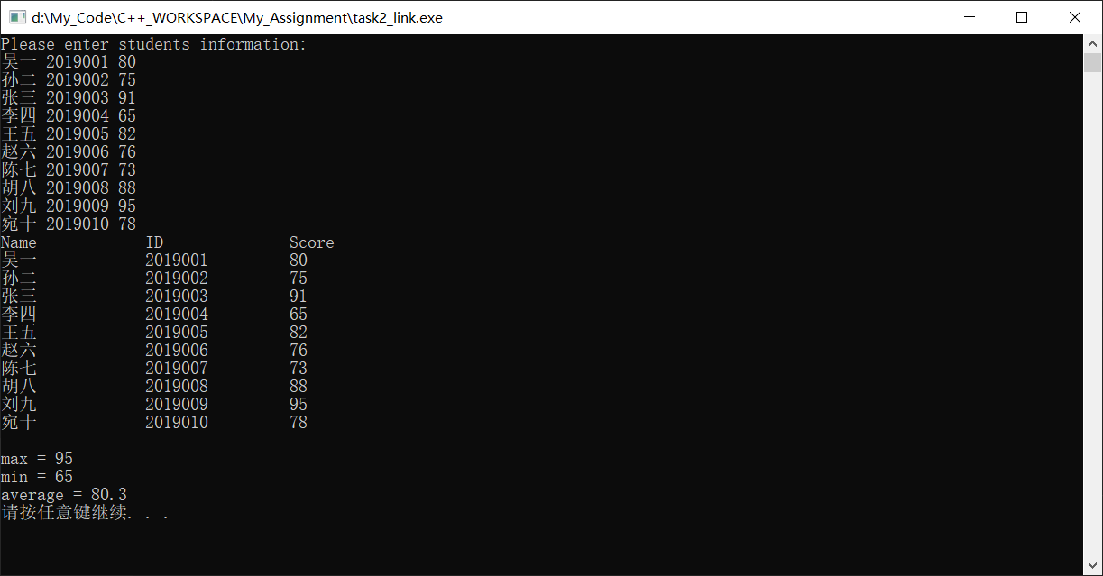

代码以下：
//输入10位同学的姓名，学号，成绩，并把这些学生的信息输出，每位学生一行。并输出最高分，最低分和平均分
#include<iostream>
#include<cstring>
#include<string>
#include<cfloat>
using namespace std;

typedef struct student{
string name;
int id;
double score;
struct student* next;
}student;

//声明
student* Creatnode(string name1,int id1,double score1);
void Add(student* currentstudent,string nam,int ID,double sco);
void Print(student* currentstudent);
void Destroy(student* currentstudent);
void Traverse(student* currentstudent);

int main(){
//初始化头结点
student* head = new student;
head->name = " ";
head->id = -1;
head->score = -1;
head->next =NULL;

int ID; //学号
double sco; //成绩
string nam; //姓名
cout << "Please enter students information: " << endl;
for(int i=0;i<10;i++){
cin >> nam >> ID >> sco;
Add(head,nam,ID,sco);
}

Print(head->next); //输出打印
cout << endl;
Traverse(head->next);
Destroy(head); //收回内存
system("pause");
return 0;
}

student* Creatnode(string name1,int id1,double score1)
{ //创建结点
student* temp = new student;
temp->name = name1;
temp->id = id1;
temp->score = score1;
temp->next = NULL;
}

void Add(student* currentstudent,string nam,int ID,double sco)
{ //增加结点
while(currentstudent->next!=NULL)
currentstudent = currentstudent->next;
currentstudent->next = Creatnode(nam,ID,sco);
}

void Print(student* currentstudent)
{ //输出学生信息
cout << "Name\t\t" << "ID\t\t" << "Score" << endl;
while(currentstudent!=NULL){
cout << currentstudent->name;
cout << "\t\t";
cout << currentstudent->id;
cout << "\t\t";
cout << currentstudent->score << endl;
currentstudent = currentstudent->next;
}
}
void Destroy(student* currentstudent)
{ //收回空间
while(currentstudent){
student* temp = currentstudent->next;
delete currentstudent;
currentstudent = temp;
}
}

void Traverse(student* currentstudent)
{
double min = DBL_MAX;
double max = DBL_MIN;
double sum = 0.0;
int cnt =0;
while(currentstudent!=NULL){
cnt++;
sum += currentstudent->score;
if(currentstudent->score < min)
min = currentstudent->score;
if(currentstudent->score > max)
max = currentstudent->score;
currentstudent = currentstudent->next;
}
double average = sum/cnt;
cout << "max = " << max << endl;
cout << "min = " << min << endl;
cout << "average = " << average << endl;
}

